Task Description:

Create a custom docker image for nginx and deploy it using docker compose, where the volume bind mount should be at /var/opt/nginx location. Push the created custom docker image to your docker-hub.
Solution :
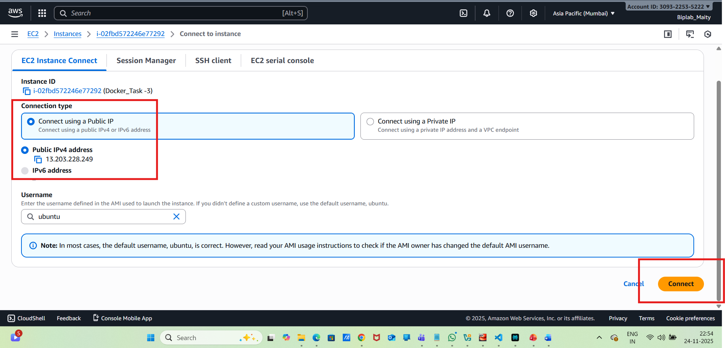
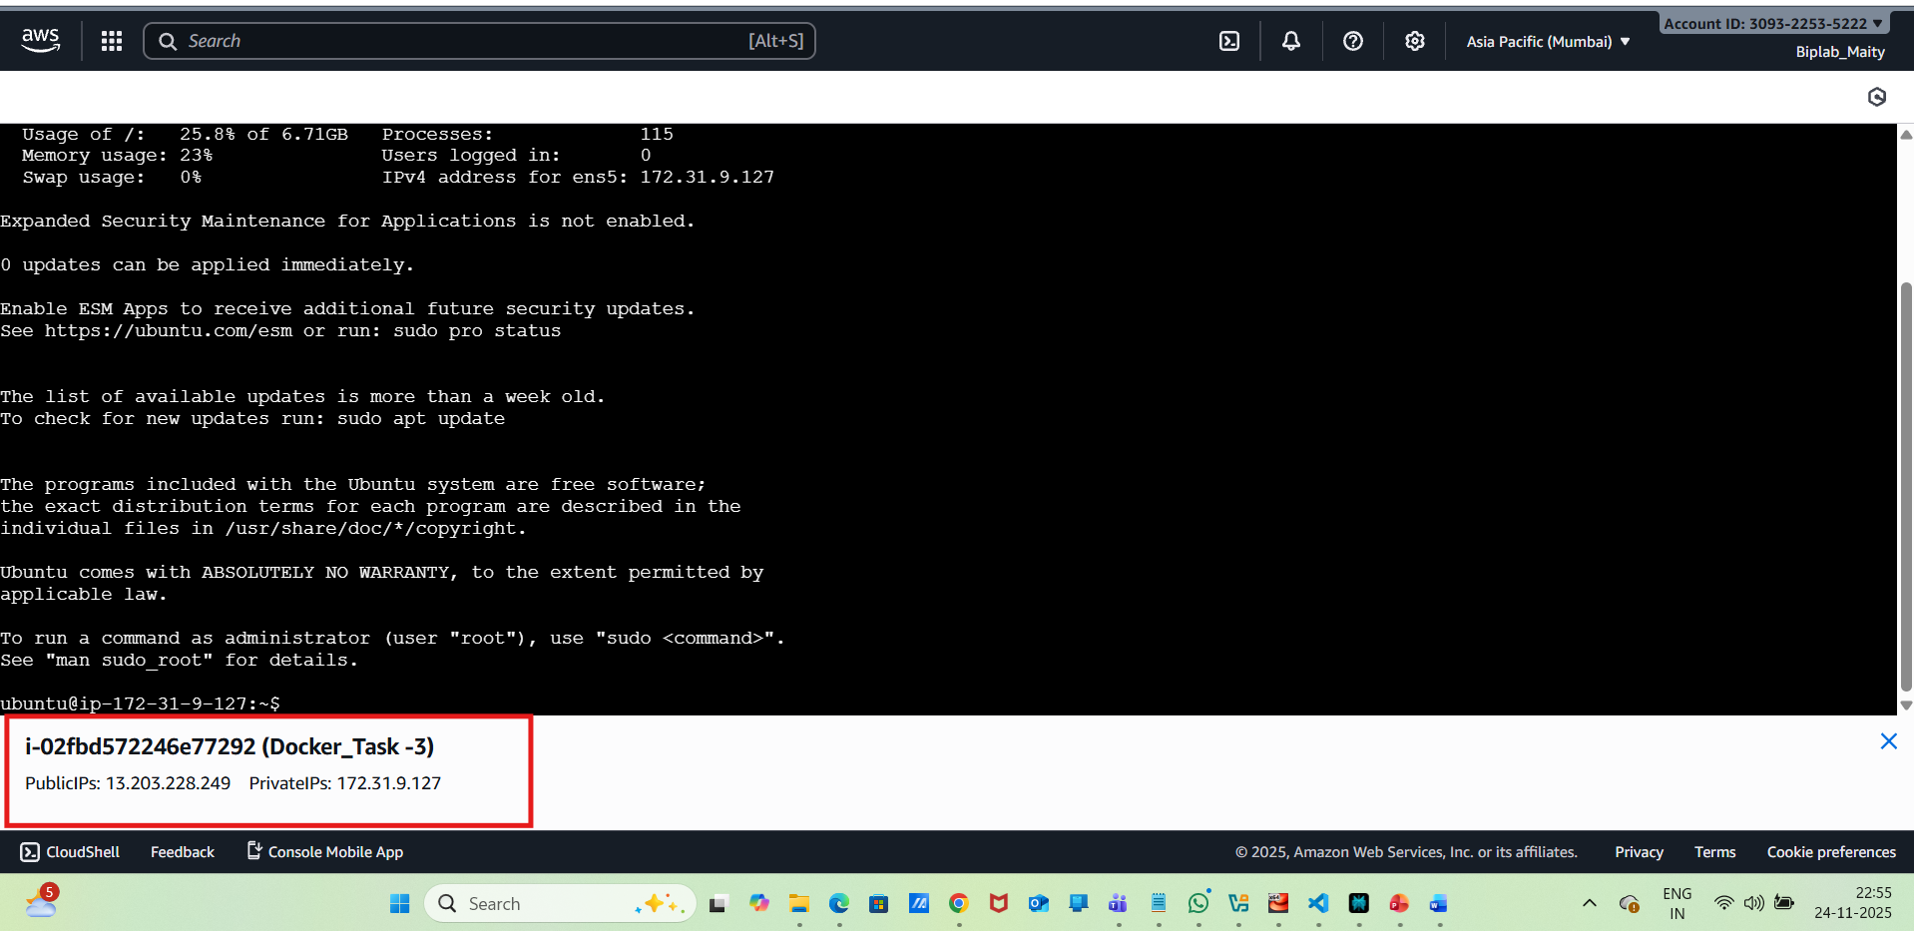
Install Docker in ubuntu :
sudo apt update -y
sudo apt install docker.io -y
sudo usermod -aG docker $USER
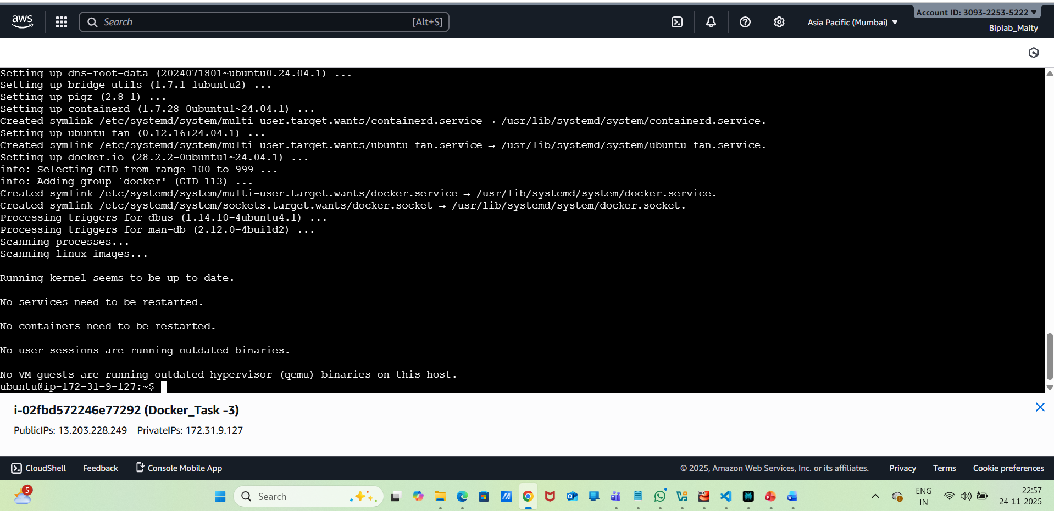
Install Docker Compose:
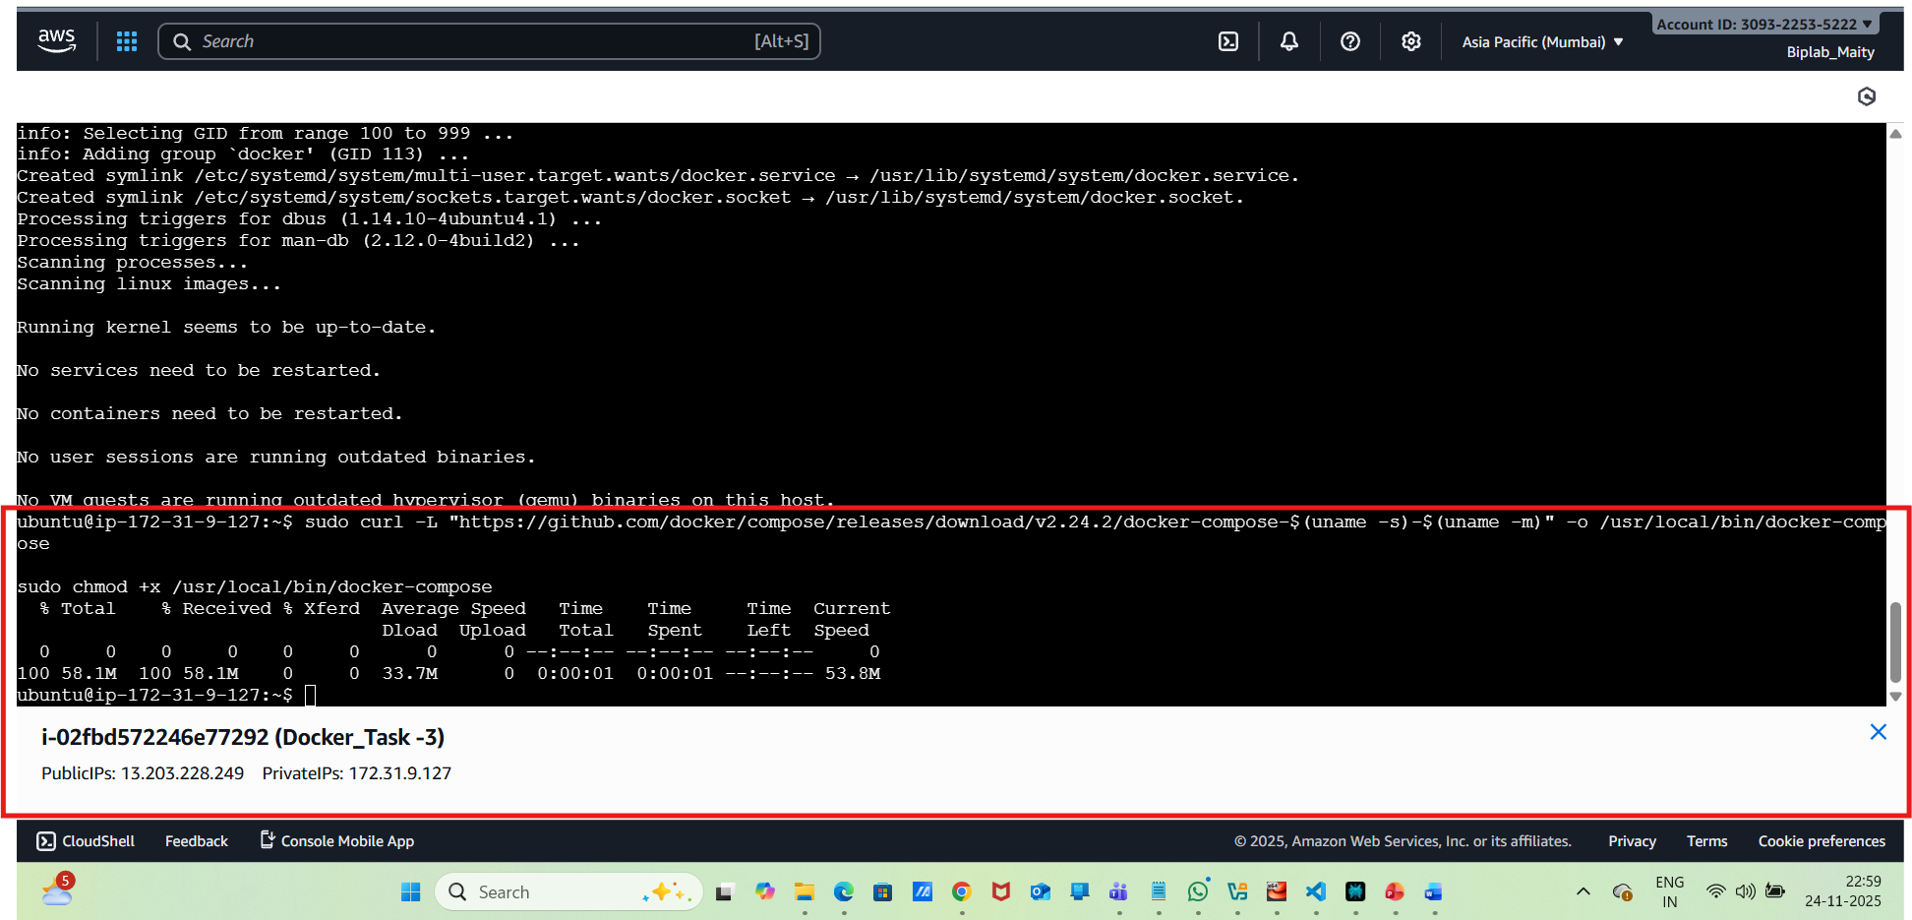
Now need to perform a Logout & log in again so the Docker group takes effect.
Create Project Directory:
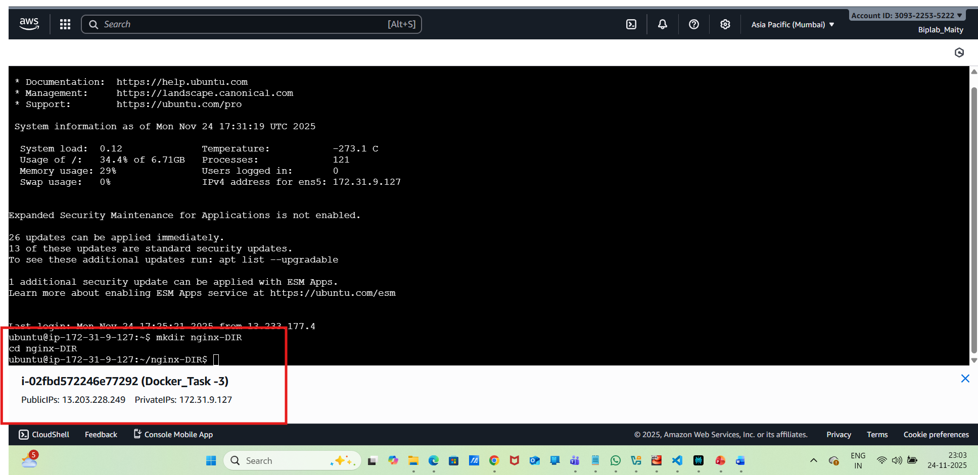
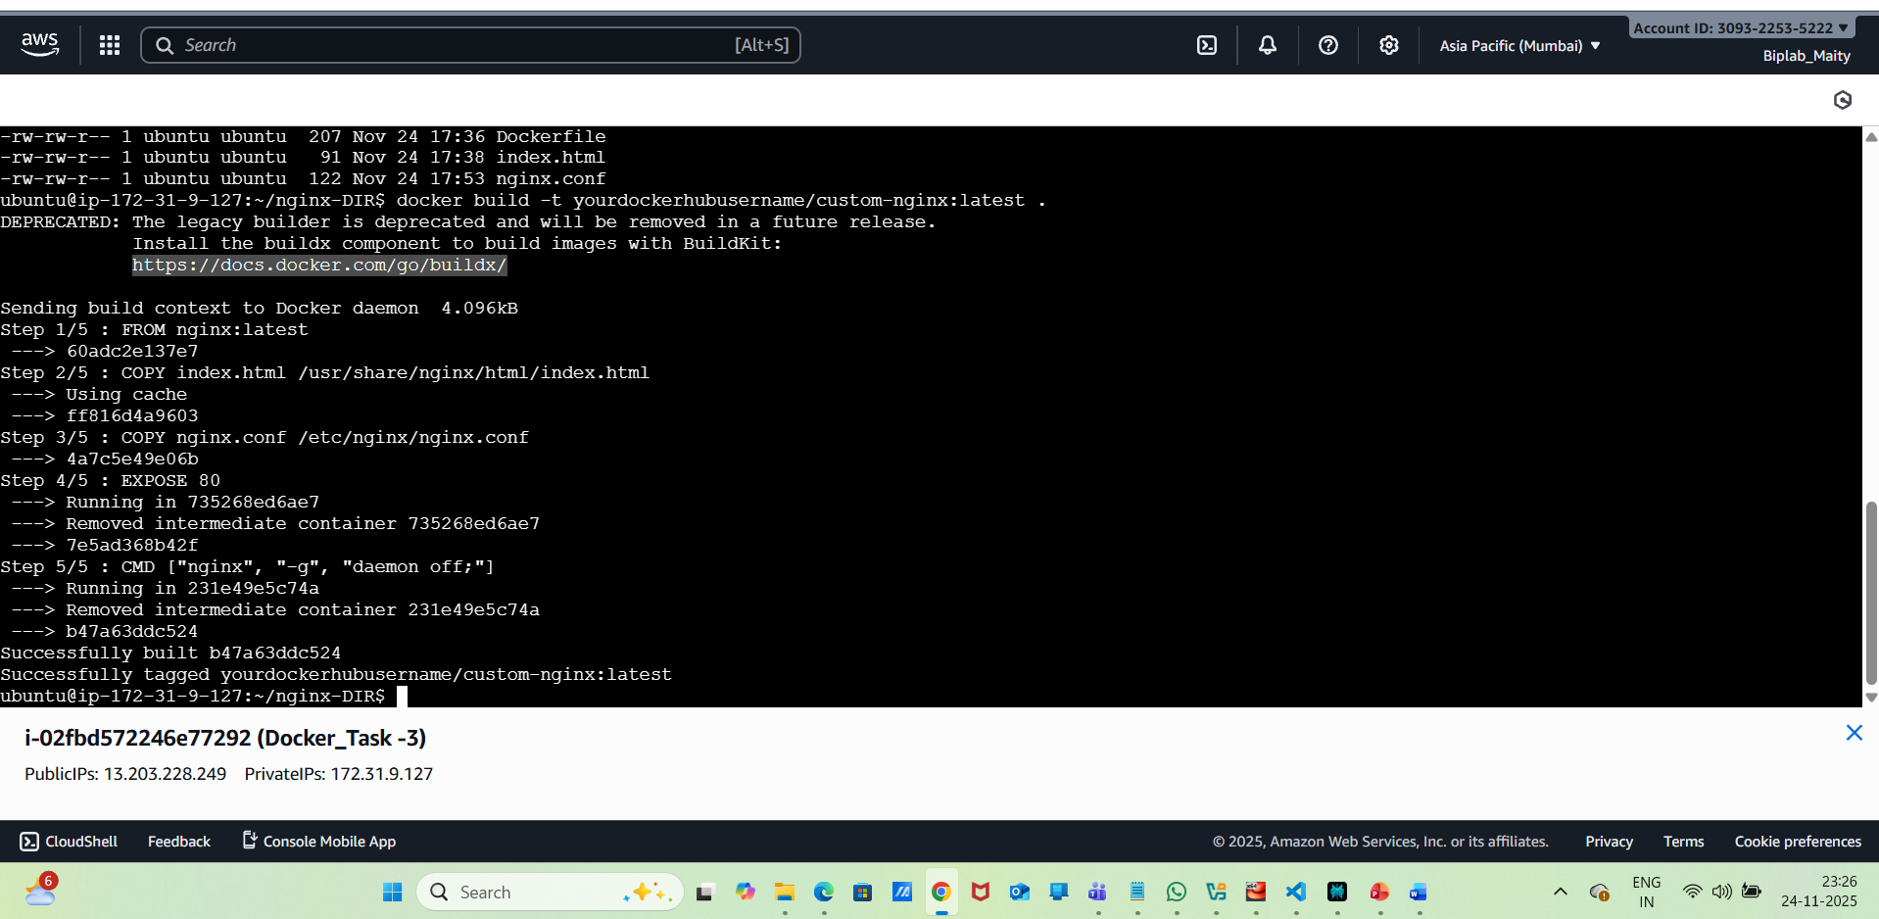
Now, Need to Create a Custom NGINX Dockerfile:
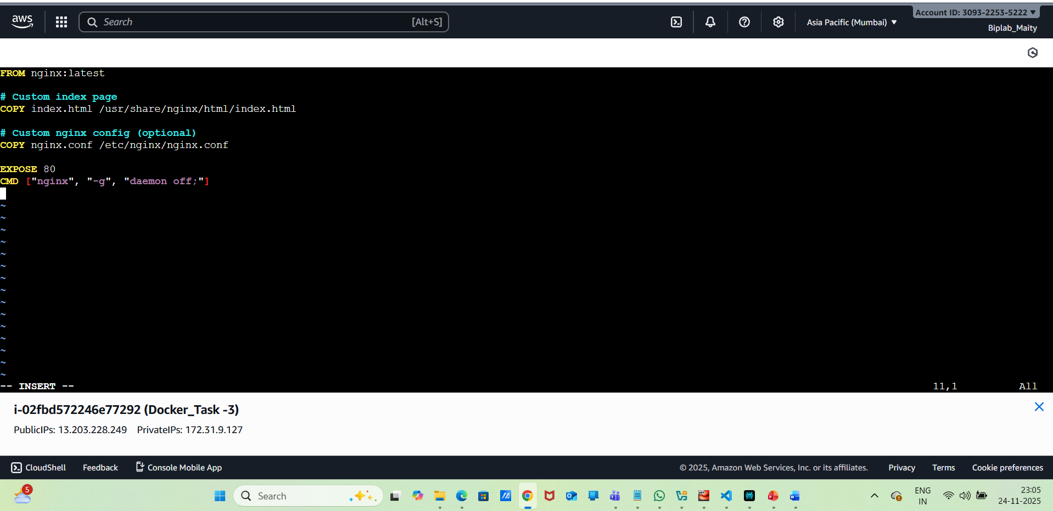
Then Add a Custom index.html:
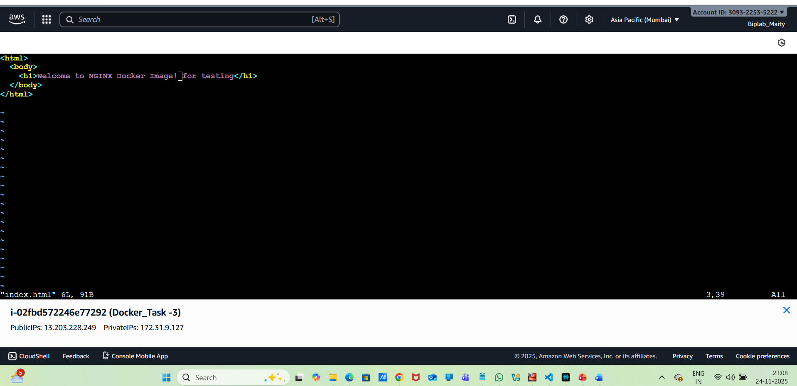
Now Build the Custom Docker Image with below command:
docker build -t yourdockerhubusername/custom-nginx:latest .
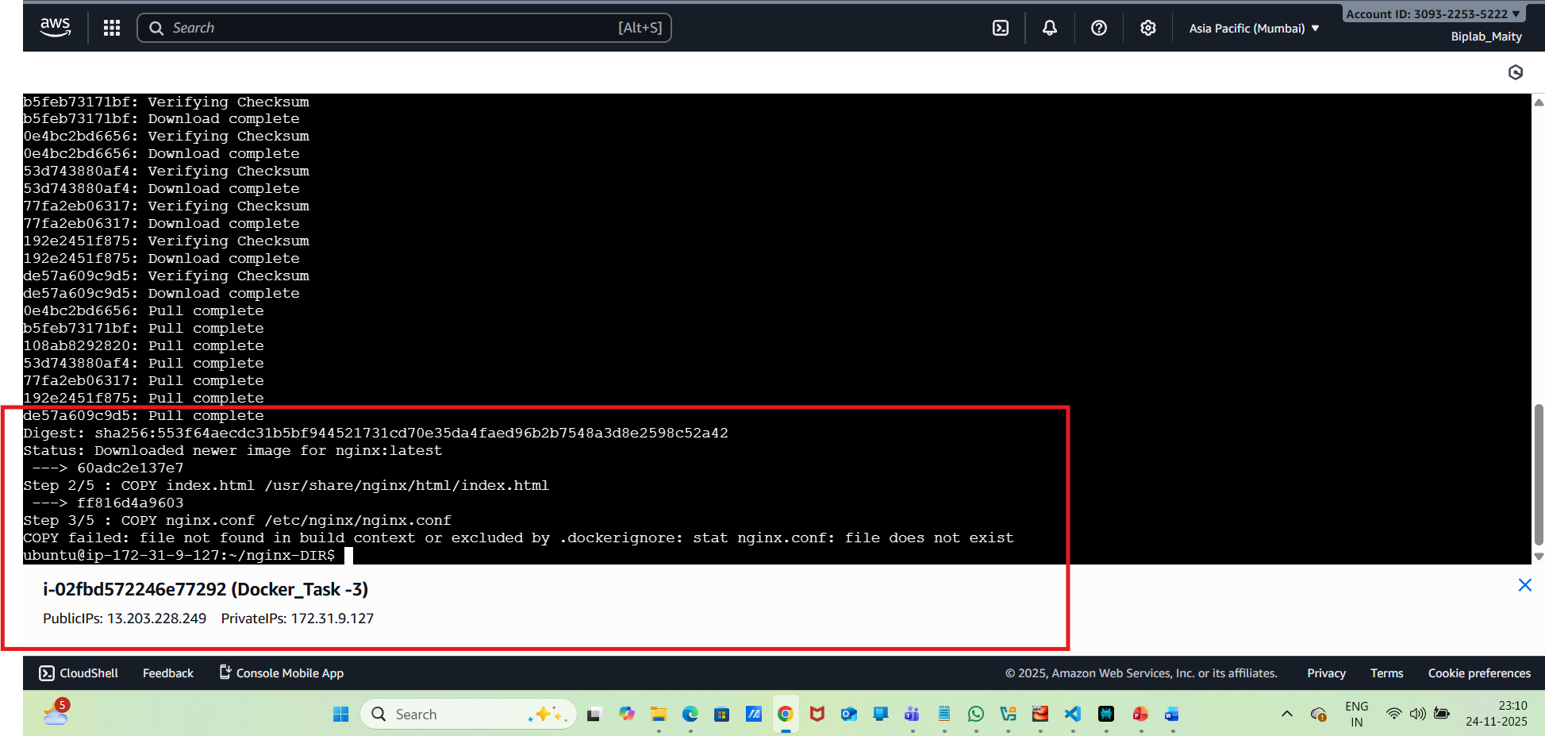
Login to Docker Hub:
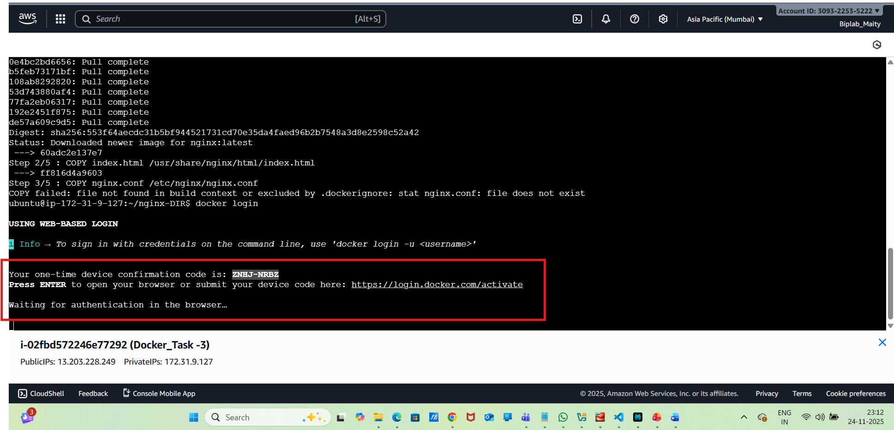
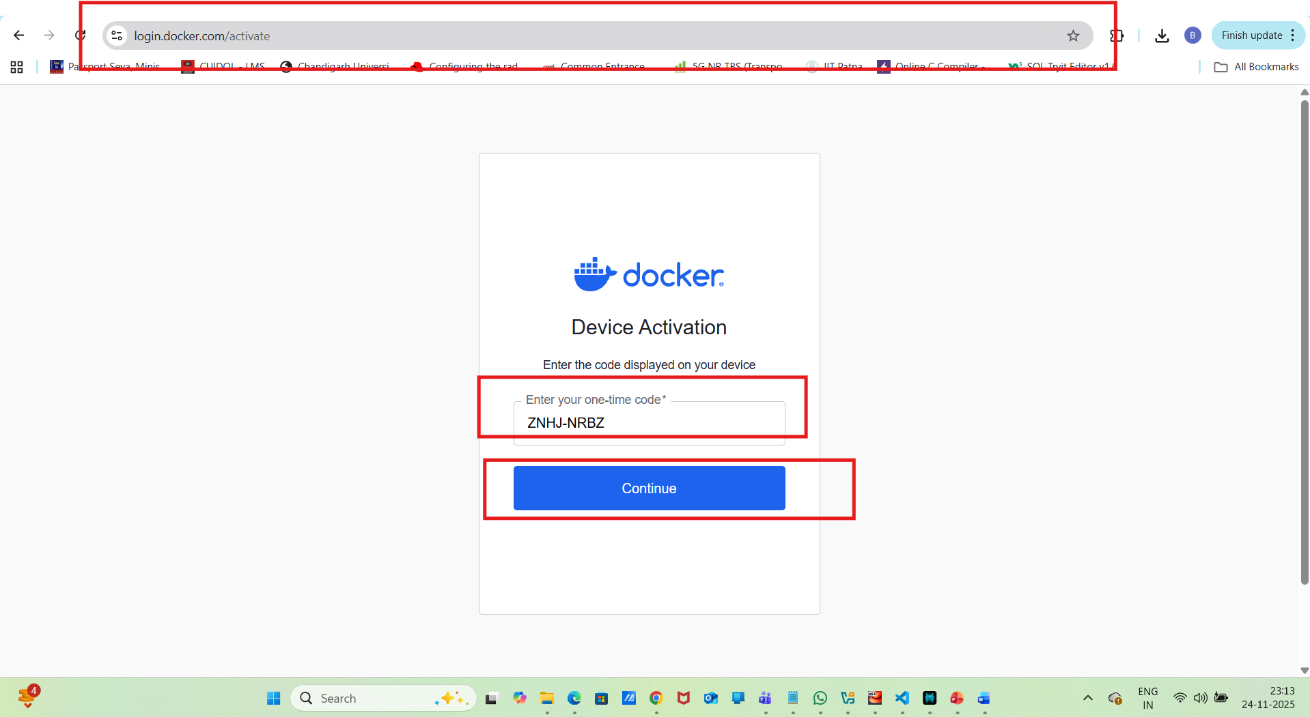
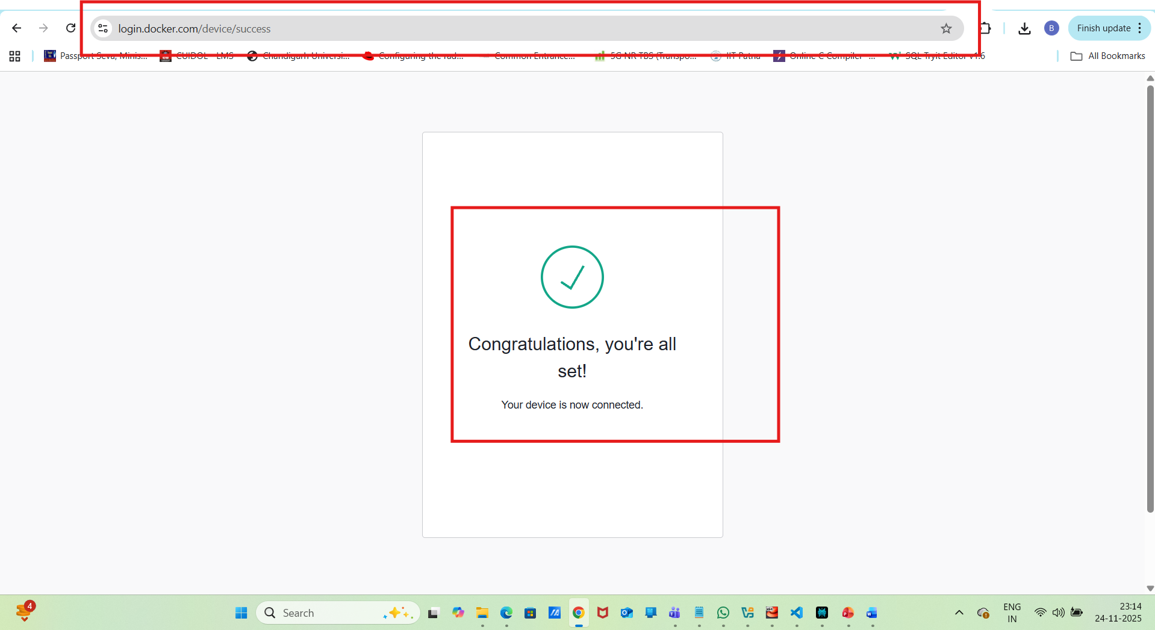
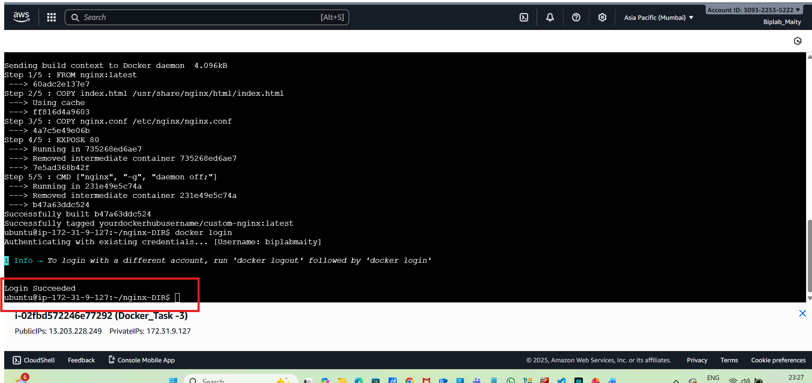
Now Push the Image to Docker Hub:
docker push yourdockerhubusername/custom-nginx:latest
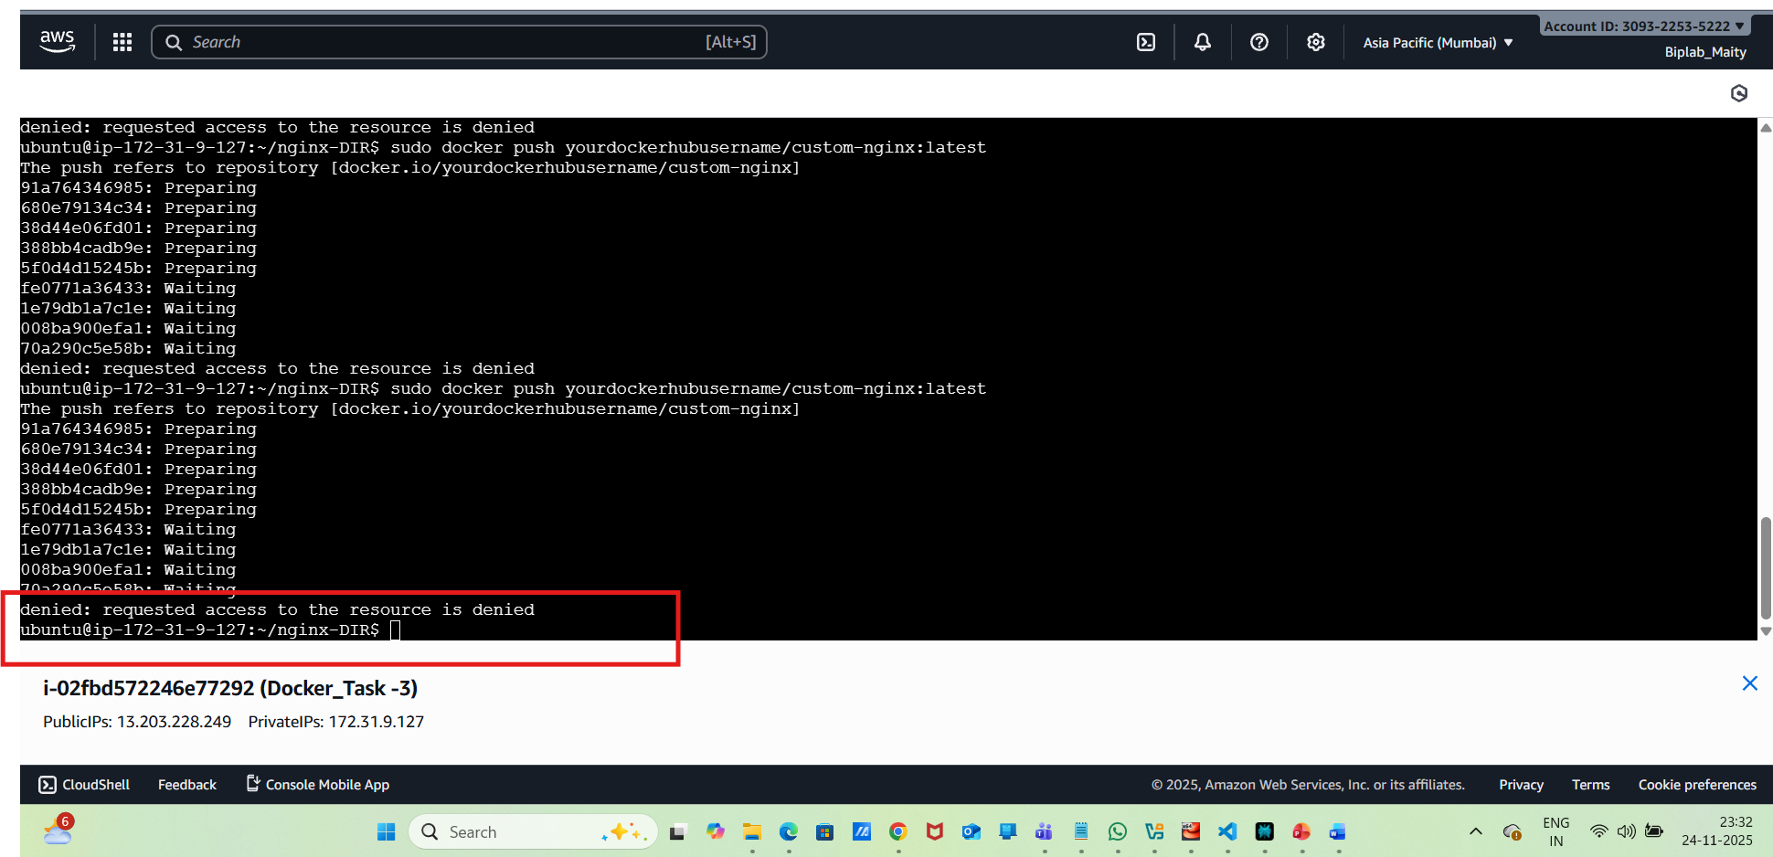
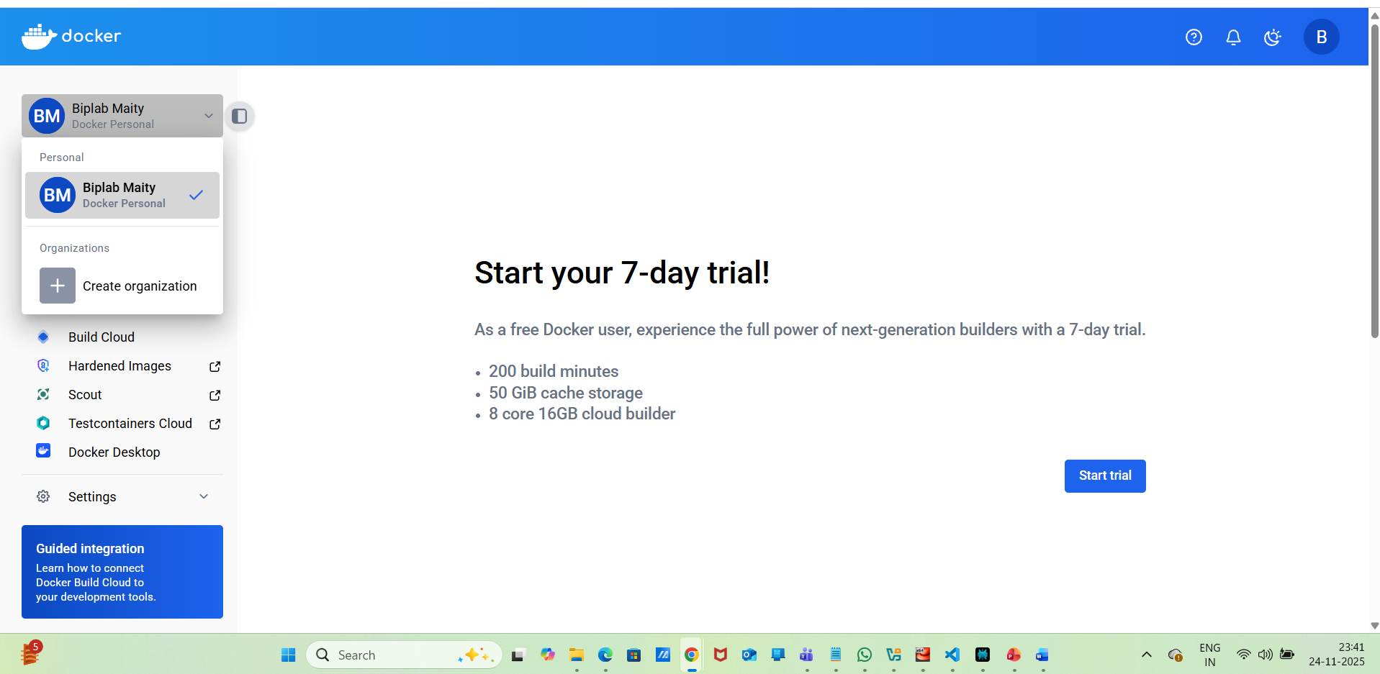
Now Ned to create Create docker-compose.yml:
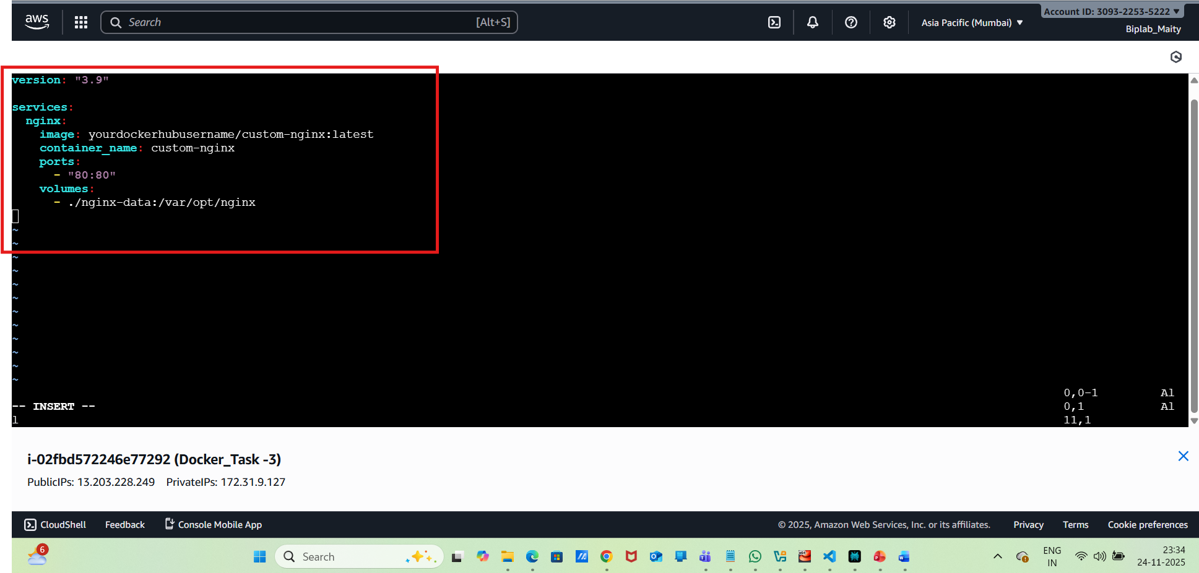
Create the Bind-Mount Directory:
mkdir nginx-data
Start the Service:

docker-compose up -d
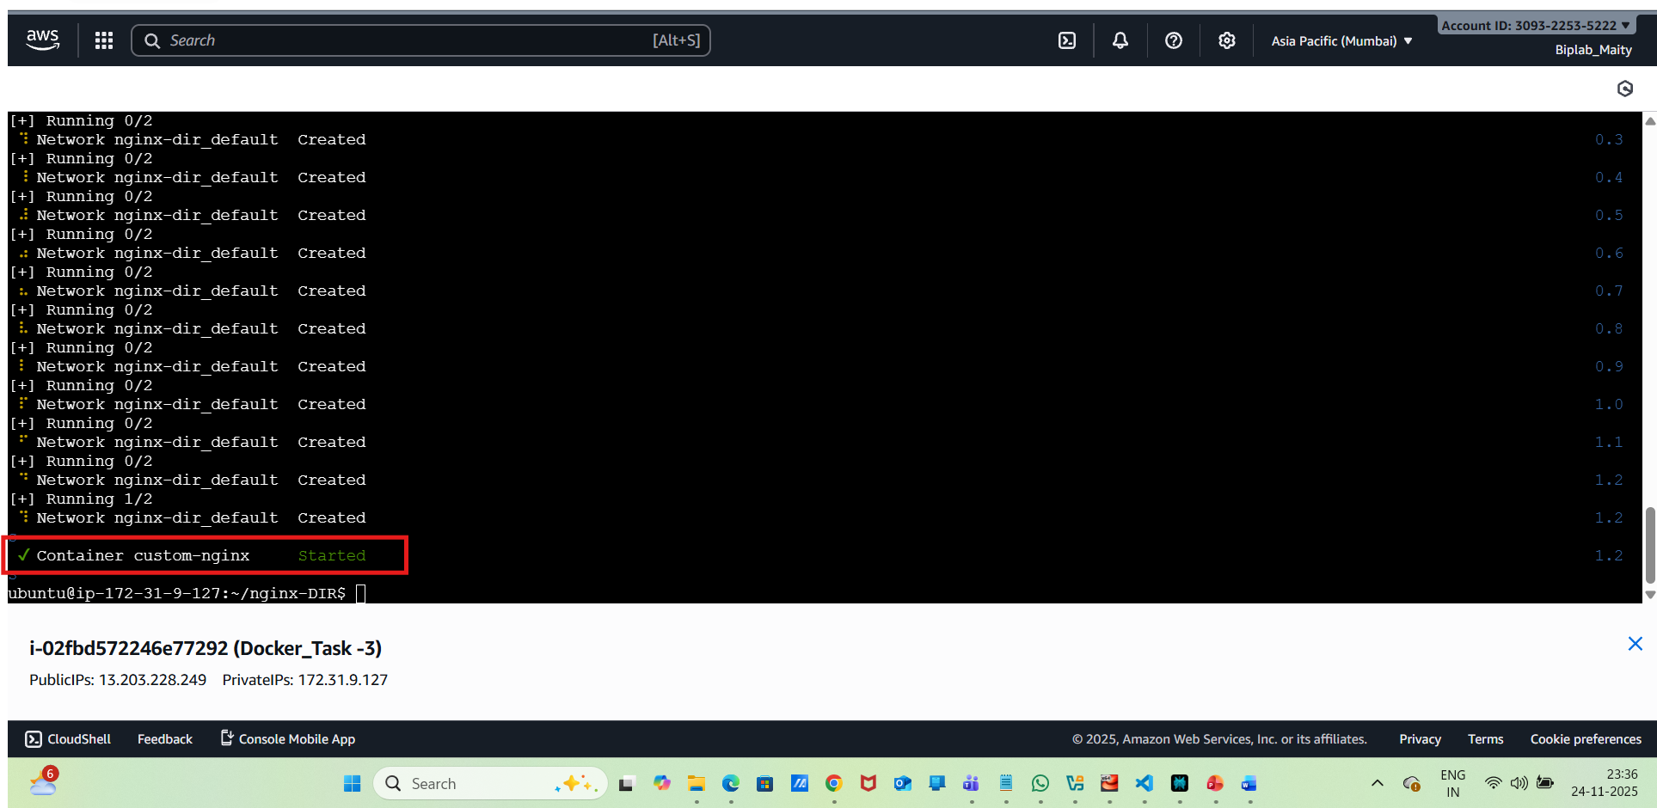
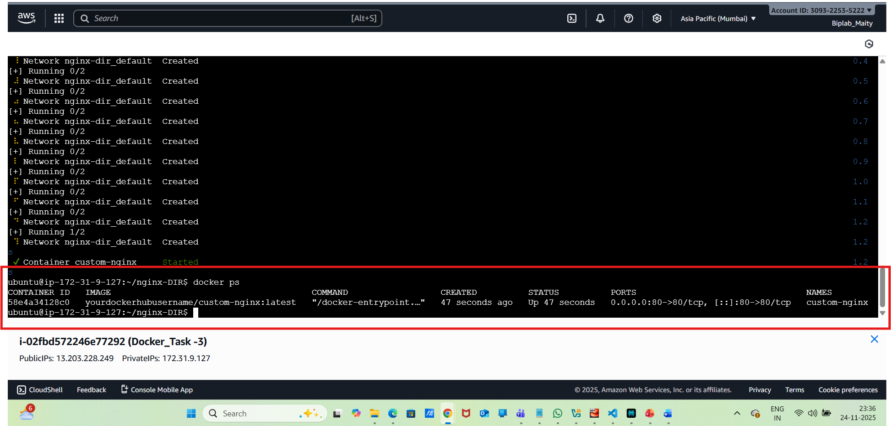
Need to check in Browser:
